230701228

Experiment no 6

Title:

Simulate the lifecycle stages for UI design using the RAD model and develop a small interactive interface using Axure RP

Aim:

The aim is to showcase the lifecycle stages of UI design using the RAD model and develop a basic interactive prototype with Axure RP, emphasizing rapid development and quick user feedback.

Procedure:

Tool Link: Axure RP

Simulating the Lifecycle Stages for UI Design Using the RAD Model

The RAD model focuses on fast development through iterative prototyping and continuous user feedback. It minimizes time spent on planning, emphasizing quick construction, testing, and delivery of functional prototypes.

Requirements Planning

In this phase, developers gather user needs and define essential features. Stakeholder discussions help in identifying UI expectations early, ensuring that the project remains aligned with user goals.

User Design

The User Design phase involves creating initial wireframes and prototypes based on user feedback. Tools like Axure RP are used to design interactive models, refining them iteratively through frequent reviews.

Construction

Construction focuses on developing the actual interface by converting prototypes into a functional product. Iterative testing is done in parallel to gather feedback and make real-time improvements based on suggestions.

Cutover

In the Cutover phase, the final prototype is deployed. Developers conduct user training sessions, address last-minute issues, and ensure that the UI is fully ready for use and further updates.

Axure RP Interactive Interface Development Phase 1: Requirements Planning

Key features like Home, Product Categories, Cart, and Checkout screens are identified. User actions such as browsing, adding to cart, and ordering are also documented for clear development goals.

Phase 2: User Design

Developers install Axure RP and start building a new project. Using the widget library, they design wireframes for each screen and begin creating basic navigations for an interactive flow.

Wireframes and Interactions

Wireframes visually map the UI screens. Developers add interactions like button clicks and page transitions, allowing users to simulate the real navigation and functionality of the final product.

Masters and Annotations

Reusable components like headers and footers are created using Masters. Annotations are added to elements to explain their purpose, functionality, and interactions, improving clarity and understanding during development.

Phase 3: Construction

In this phase, wireframes are made fully interactive. Developers integrate dynamic panels, carousels, and pop-ups, performing multiple testing rounds and refining the prototype according to user feedback.

Phase 4: Cutover

The project is finalized and exported. Developers share the prototype through HTML or Axure Cloud, conduct user training sessions, and provide support documents for smooth usage and transition.

Output:

Screenshots or exported HTML versions of the interactive food ordering application created using Axure RP are produced, showcasing the navigation and functionality through a working prototype.

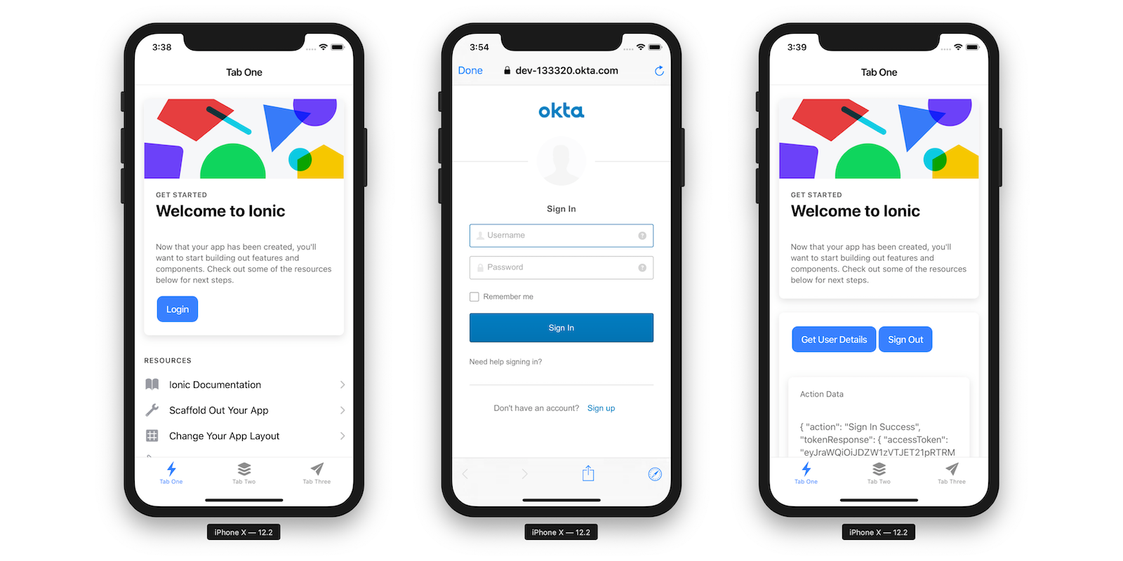

Result:

Thus, the lifecycle stages of UI design via the RAD model were successfully demonstrated, and a functional interactive interface prototype was developed using Axure RP as a tool.